# Machine Learning Week 4 Progress Report

Group Members:

Aarya Parekh AU2120075

Diya Patel AU2120193

Kavyan Savani AU2120231

Vatsal Shah AU2040082

**18-03-2024**

Plotting the vehicles for two datasets:

This week, we extracted datasets of 2 time frames from Pneuma and preprocessed this data to remove noise such as motorcycles, buses, and taxis.

After this, we plotted the initial position of vehicles and trajectories throughout their existence in the frame

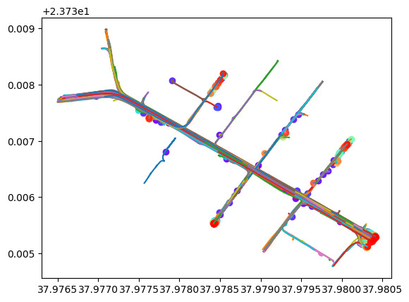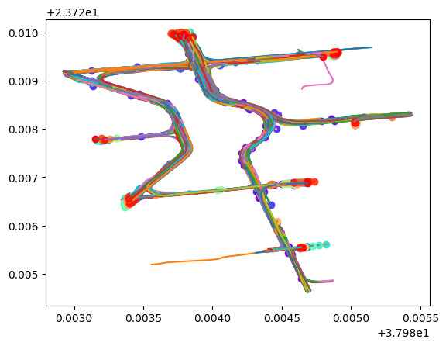

**20-03-2024**

Calculating the Azimuth Angle:

Next, we had to calculate the Azimuth angle to determine the direction of the road.

For this, we calculated the Azimuth angle in two different ways.

Record-wise - In this method, we calculated azimuth angles between consecutive longitude values in a given record, using corresponding latitude values of all the vehicles at a given timestamp.

Vehicle-wise - In this method, we first calculated the change in longitude between the starting and ending timestamps for a vehicle, got the starting and ending latitudes for that vehicle, and then calculated the azimuth angle for those longitude and latitude values.

**21-03-2024**

Faux azimuth angle:

Since in the base paper, no true directions were given, and there was no mention of what the authors thought of when they said true north, we decided to go by determining the direction angle ourselves. For this, we took out the two vectors, latitudinal acceleration and longitudinal acceleration, as two acceleration components, using which we found the angle between the acceleration vector and the x-axis(latitudinal line).

Road breakup:

We brainstormed and decided to take up sections of the road of similar length rather than using the whole road as roads can be curvy, but a small section can be assumed to be straight. We would then detect the number of lanes on every given section of the road using our clustering algorithm. This gives us further information and enables the algorithm to learn and predict the following road sections. We are still determining if this idea will work, but we are hopeful it will work.

**Future Goals/Aims**

Our target is to implement our current idea of faux azimuth angle and breaking up the road. We believe this will give us novel insights into the dataset, as the pre-existing approach was not detailed enough.

References

1. Barmpounakis, Emmanouil, Guillaume M. Sauvin, and Nikolaos Geroliminis. "Lane detection and lane-changing identification with high-resolution data from a swarm of drones." Transportation research record 2674.7 (2020): 1-15.